Calusa Elementary School

Car Rider Protocol 22-23



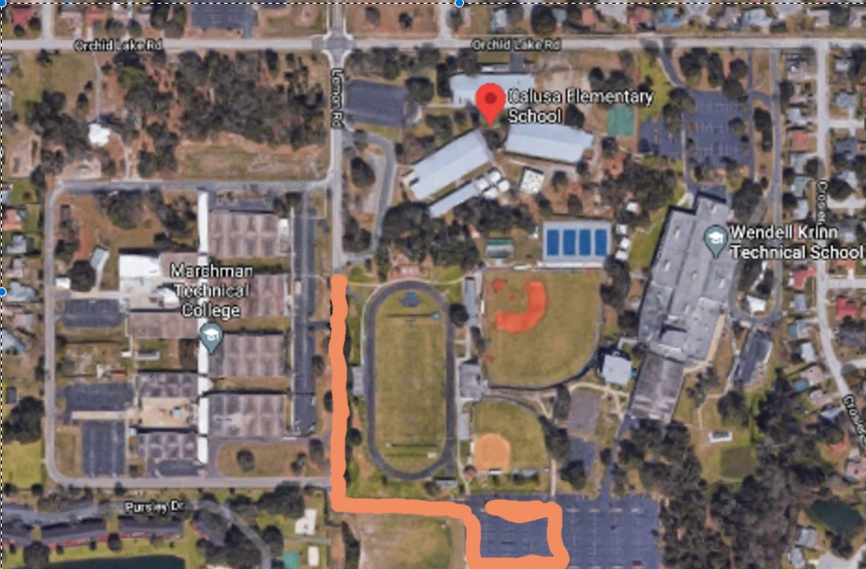

**Arrival:** All families may drop off their student(s) in the front car loop located off of Lemon Rd & Campus Drive. Staff will begin opening car doors at 9:50 am. Students are not permitted on campus prior to 9:50 am due to lack of adult supervision.

**Dismissal:** In order to ensure the safety and security of our students’ families will need to have a car tag displayed in your window. If you do not have a car tag, you will be asked to park and proceed to the front office to verify ID and receive a temporary tag. Please be patient during this process.

**Primary Students- Grades K-2:** If you are picking up a student in grades K-2 please drive down Campus Drive to the end make a left into the K-Tech football parking lot & make U-Turn into car line.

**Intermediate Students- Grades 3-5:** If you are picking up a student in grades 3-5, you will enter through K-Tech’s front parking lot off of Orchid Lake Road.

**\*\*\*Please Note**: If you have students in both primary and intermediate, please use the primary front car line.