We Need You!

Why does your support make a difference?

As a community working together to ensure our students, our future leaders…

- Build positive relationships
- Communicate effectively
- Think Critically
- Have self confidence
- Are prepared for college, career, and life

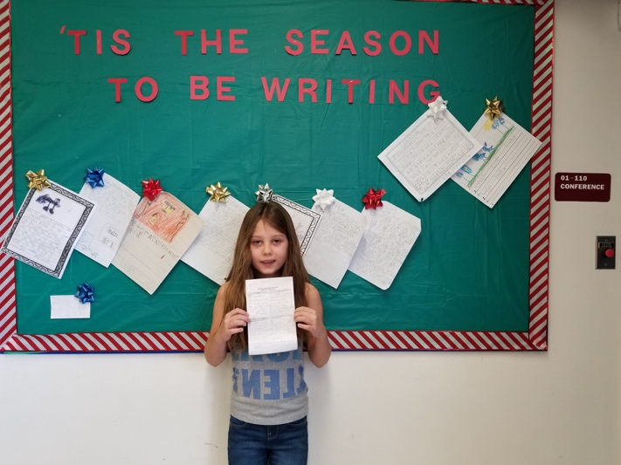

School Resources

Mrs. Michelle Hartman, Principal
Thartman@pasco.k12.fl.us

Ms. Tammy Sutula, Asst. Principal
Tsutula@pasco.k12.fl.us

Registrar, Melissa Schwartz
Mschwart@pasco.k12.fl.us

Bookkeeper, Mary Bandini
Mbandini@pasco.k12.fl.us

Secretary, Dawn Brandenburg
Kbranden@pasco.k12.fl.us

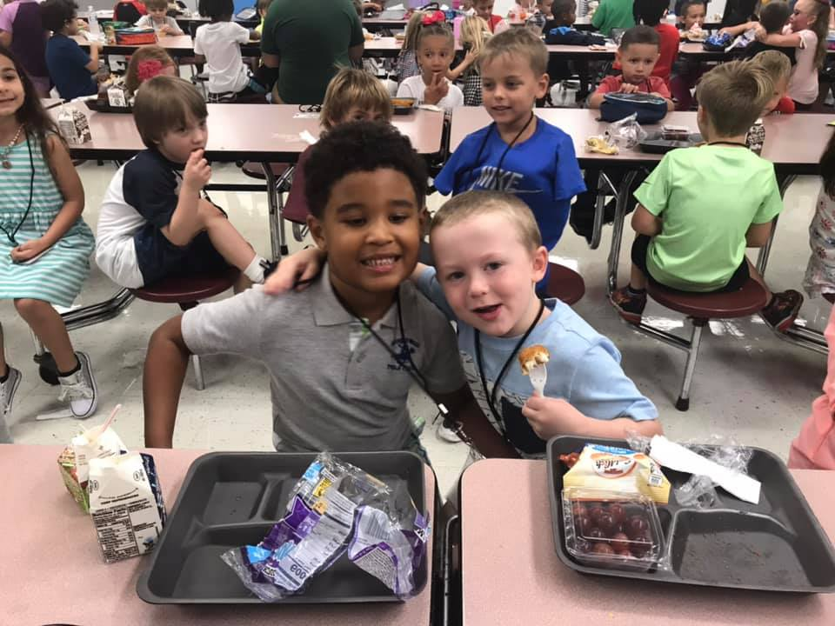

#STRONGERTOGETHER
Calusa Elementary

Established 1979

7520 Orchid Lake Road
New Port Richey, FL 34653
(727) 774-3700

Family & Community Engagement

Home Learning Environment

Strategies you can use at home with your child!

- Establish a nightly routine for school communication, homework, bed time, etc.
- Check your child’s backpack daily
- Provide a quiet place and resources (books, pencils, paper, crayons) for completing homework.
- Provide opportunities for discovery (cooking together, nature walks, museum’s)

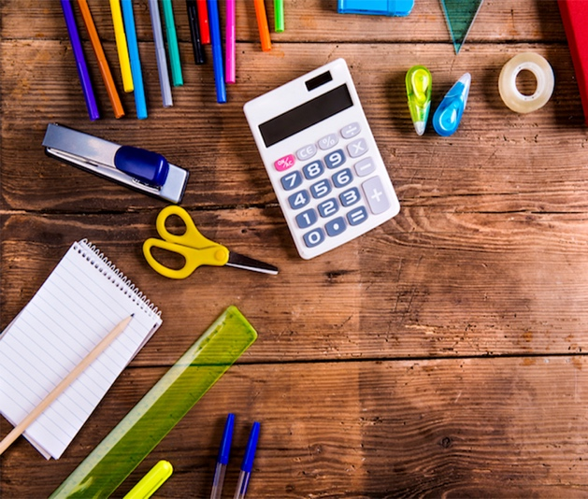

Stay Connected

Communication between home and school= your child’s success!

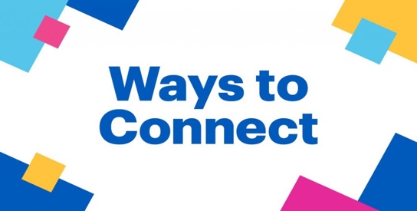

- Register and monitor your Parent Portal on myStudent
- Look for notes in your child’s school planner or folder
- Follow Class Dojo messages
- Attend parent/ teacher conferences regularly
- Visit the school webpage for upcoming events and announcements
- http://caes.pasco.k12.fl.us

- Watch for Hawk Happenings on Facebook http://facebook.com/CalusaESpasco

- Listen to our monthly call

Involvement

Become a Volunteer

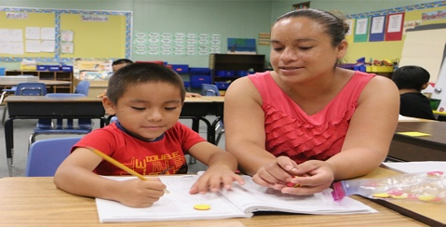

There are many opportunities to participate.

- Volunteer in the classroom
- Lunchroom assistance
- Chaperone Field Trips
- Participate in PTO (Parent Teacher Organization)
- Join SAC (School Advisory Council)

We value your time and dedication to Calusa!

