Testing Log In on macOS Devices
This process applies to on site and take-home devices issued by Pasco County Schools
ON CAMPUS - Process Steps (State and NWEA MAP Testing)
- From the Log In screen, click in the name field and use the following credentials: aplus / aplus.
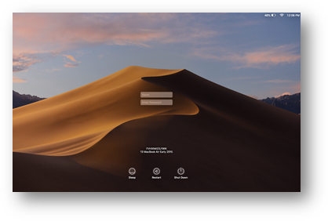
- This will bring you into the testing account’s environment. This will include a Dock populated with the FSA Secure Browser, the Chrome Browser and the NWEA Secure Browser.
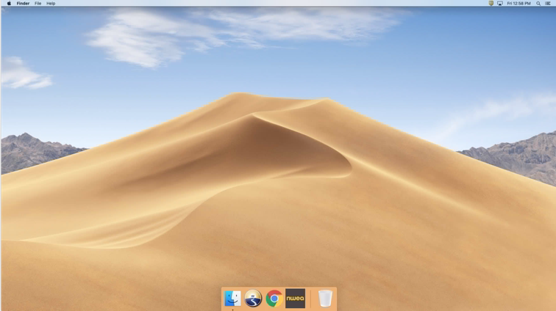
  - FSA Secure Browser is used for state-based assessments.
  - NWEA Secure Browser is used for MAP Growth assessments
- Select the appropriate testing platform.
- Log in using the credentials your testing coordinator supplies or instructs you to use.

ON CAMPUS - Process Steps (myProgress Assessments)

- From the Log In screen click in the name field.
- Type Guest and hit return twice.
- This will bring up the Guest desktop, Click the myPascoConnect Dock icon.
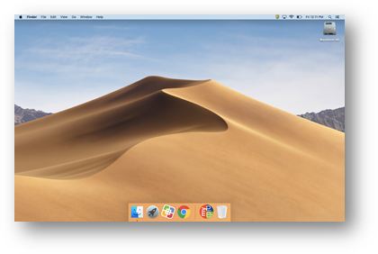
- Log in with your myPascoConnect credentials.
- To take a myProgress assessment open Chrome, go to myPascoConnect and log in.
- Locate and click the myProgress icon and log in with your myProgress credentials if required (Username: 6-digit Student ID and Password: District Provided Password).

OFF CAMPUS - Process Steps (NWEA MAP Assessments)
When taken off site NWEA assessments should use the Chrome Browser, when taken on site make sure to use the NWEA Secure Browser.
THE FSA SECURE BROWSER CANNOT BE USED OFF CAMPUS.
- From the Log In screen click in the name field.
- Type Guest and hit return twice.
- This will bring up the Guest desktop, Click the myPascoConnect Dock icon.
- Log in with your myPascoConnect credentials.
- Locate the Icon for NWEA MAP and launch it.
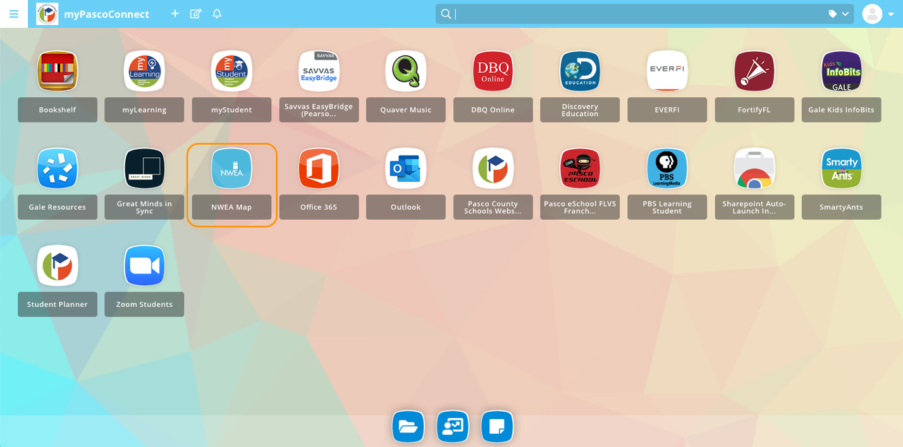
- This will pop up a new window for the NWEA MAP assessment.
- Access the test using the credentials your testing coordinator supplies or instructs you to use. Make sure to access your testing coordinator’s Zoom meeting if it is provided to you. Instructions for using Zoom may be found HERE.
