Testing Log In on Windows Devices
This process applies to on site and take-home devices issued by Pasco County Schools
ON CAMPUS - Process Steps
- From the Log In screen select “Other User” Account in the bottom left hand corner.
- Log in using myPascoConnect credentials.
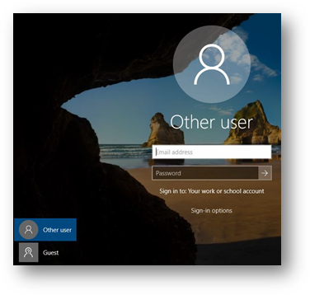
- Select the Windows Start button in the bottom left corner of the desktop and navigate to the appropriate testing platform.
  - FL Secure Browser is used for state-based assessments.
  - Google Chrome is used for myProgress/Performance Matters
  - NWEA Secure Browser is used for MAP Growth assessments
- After selecting the appropriate testing platform, click the icon to launch it.
- To take a myProgress assessment open Chrome, go to myPascoConnect and log in.
- Locate and click the myProgress icon and log in with your myProgress credentials if required (Username: 6-digit Student ID and Password: District Provided Password).
- Log in using the credentials your testing coordinator supplies or instructs you to use.

OFF CAMPUS - Process Steps
- From the Log In screen select “Other User” Account in the bottom left hand corner.
- Log in using myPascoConnect credentials.
- Select the Windows Start button in the bottom left corner of the desktop and navigate to the appropriate testing platform.
  - Google Chrome is used for myProgress/Performance Matters and NWEA browser-based assessments
When taken off site NWEA assessments should use the Chrome Browser, when taken on site make sure to use the NWEA Secure Browser.
THE FSA SECURE BROWSER CANNOT BE USED OFF CAMPUS.
- To take a myProgress assessment open Chrome, go to myPascoConnect and log in.
- Locate and click the myProgress icon and log in with your myProgress credentials if required (Username: 6-digit Student ID and Password: District Provided Password).
- If you are taking a NWEA MAP assessment use Chrome and go to myPascoConnect.
- Locate the Icon for NWEA MAP and launch it.

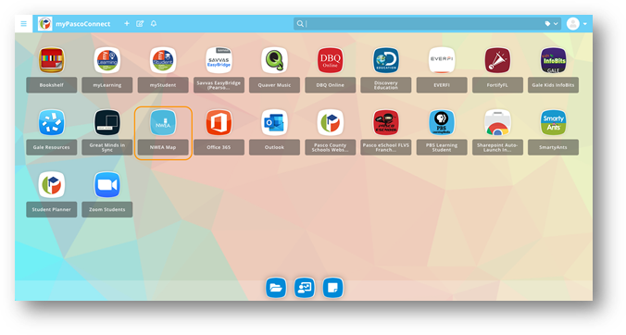
- This will pop up a new window for the NWEA MAP assessment.
- Access the test using the credentials your testing coordinator supplies or instructs you to use. Make sure to access your testing coordinator’s Zoom meeting if it is provided to you. Instructions for using Zoom may be found HERE.
