Testing Log In on Personal Devices
This process applies to personal devices used to access Pasco County Schools testing resources. This process applies to myProgress and NWEA MAP assessments only.
NWEA MAP ASSESSMENTS MAY ONLY BE TAKEN ON A PERSONAL DEVICE IF YOU ARE OFF CAMPUS
THE FSA SECURE BROWSER CANNOT BE USED OFF CAMPUS OR ON A PERSONAL DEVICE.

ON CAMPUS - Process Steps (myProgress Assessments)
- Log into your device
- Open Google Chrome, the supported browser for all Pasco County Schools services
- Navigate to https://mypascoconnect.pasco.k12.fl.us
- Log in using myPascoConnect credentials.
- Locate and click the myProgress icon and log in with your myProgress credentials if required (Username: 6-digit Student ID and Password: District Provided Password).
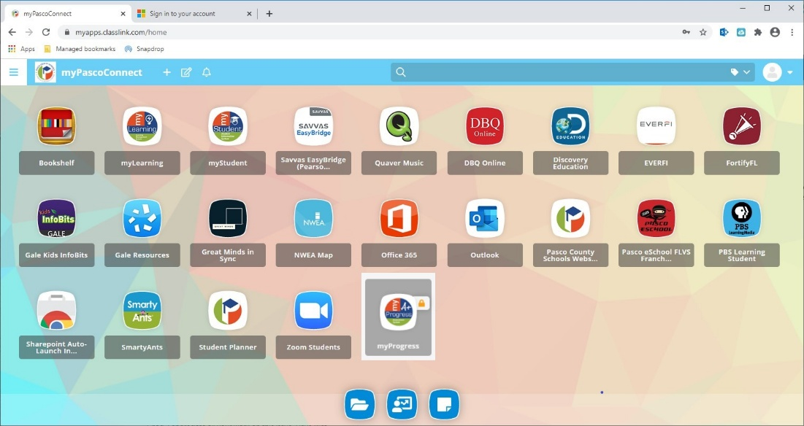

OFF CAMPUS - Process Steps (my Progress and NWEA MAP Assessments)

- Log into your device
- Open Google Chrome, the supported browser for all Pasco County Schools services
- Navigate to https://mypascoconnect.pasco.k12.fl.us
- Log in using myPascoConnect credentials.
- If you are taking a myProgress assessment, locate the myProgress icon and launch it. Log in with your myProgress credentials if required (Username: 6-digit Student ID and Password: District Provided Password).
- If you are taking a NWEA MAP assessment, locate the Icon for NWEA MAP and launch it.
- This will pop up a new window for the NWEA MAP assessment.
- Access the test using the credentials your testing coordinator supplies or instructs you to use. Make sure to access your testing coordinator’s Zoom meeting if it is provided to you. Instructions for using Zoom may be found HERE.
