Calusa Elementary School
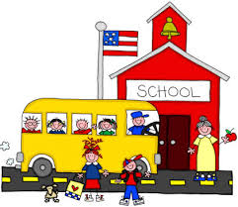
2nd Grade Supply List

- Personal pencil box
- 1 pack of glue of sticks
- 4- Composition Books
- 3- 12 packs of #2 pencils (pre-sharpened)
- 1 Box of Crayola crayons
- 1- Pair of Fiskars Scissors
- 4- Double pocket 3-pronged folders (plastic)
- 2- Boxes of tissues
- 2- Boxes of Baby Wipes
- 2- Disinfectant wipes
- 1- Hand Sanitizer
- 2- Boxes of Ziploc bags (one sandwich and one gallon size)
- 2- Reams (package) of printer/copier paper
- 4- Packs of dry erase markers (black)
- 2- Packages of erasers
- 2- Packs of index cards
- 2- Packs of post-it notes
- 1 Zipper (fabric) pencil pouch

Please only write student names on pencil box.

Thank you for your support!

